**Sindh:**

Mazar-e-Quaid

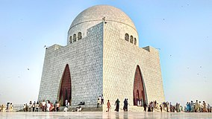

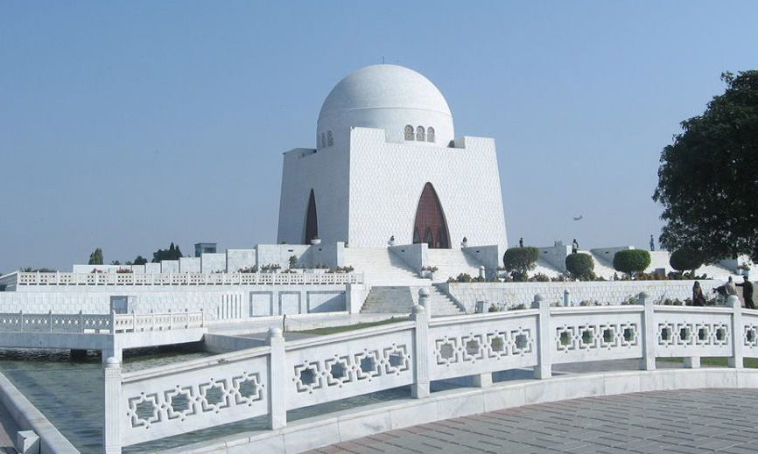

**Mazar-e-Quaid** also known as the **Jinnah Mausoleum** or the **National Mausoleum**, is the final resting place of Quaid-e-Azam ("Great Leader") Muhammad Ali Jinnah, the founder of Pakistan. Designed in a 1960s modernist style, the mausoleum also contains the tomb of his sister,Māder-e Millat ("Mother of the Nation") Fatima Jinnah, and that of Liaquat Ali Khan, the first Prime Minister of Pakistan.